TASK #1

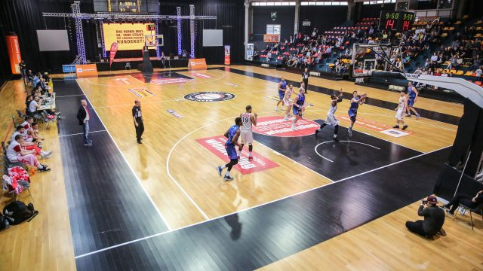

Basketball players mainly use skills such as dribbling, shooting, running and jumping.

TASK #2

|  |  |  |  |  |  |
| --- | --- | --- | --- | --- | --- |
| (1,1) | (1,2) | (1,3) | (1,4) | (1,5) | (1,6) |
| (2,1) | (2,2) | (2,3) | (2,4) | (2,5) | (2,6) |
| (3,1) | (3,2) | (3,3) | (3,4) | (3,5) | (3,6) |
| (4,1) | (4,2) | (4,3) | (4,4) | (4,5) | (4,6) |
| (5,1) | (5,2) | (5,3) | (5,4) | (5,5) | (5,6) |

Task #3

Task #4

TASKL #5

INTRODUCTION TO COMPUTING

My name is Rida. This is a sample writing to let you understand that how you should write your introduction.

You can use different fonts and sizes as I have in this particular line.

You are fully allowed to do experiments as we all are learn from them.